$$1,00 Gs=1,00·{10}^{9} s$$
$$1 yr=365 d·\frac{24hr}{d}·60\frac{min}{hr}·60\frac{s}{min}=31.536.000 s$$
$$antal år=\frac{1,00·{10}^{9} s}{31536000 s}=\frac{62500}{1971}≈31,7$$
Altså går der 31,7 år

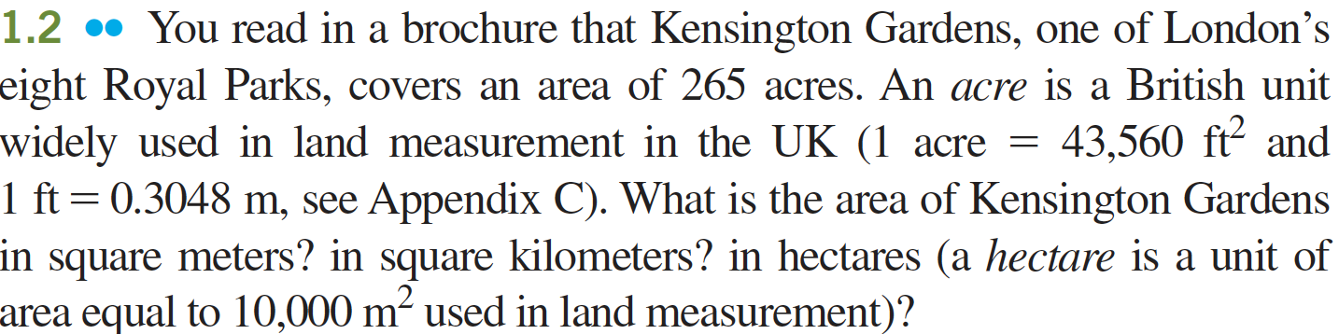

$$A\left[m^{2}\right]=265 acre=265 acre·43560\frac{ft^{2}}{acre}·{\left(0,3048\right)}^{2}\frac{m^{2}}{ft^{2}}=\frac{16756514874}{15625}m^{2}≈1.07·{10}^{6} m^{2}$$

$$A\left[{km}^{2}\right]=\frac{265 acre·43560\frac{ft^{2}}{acre}·{\left(0,3048\right)}^{2}\frac{m^{2}}{ft^{2}}}{{1000}^{2}\frac{m^{2}}{km^{2}}}=\frac{8378257437}{7812500000}km^{2}≈1,07 km^{2}$$

$$A\left[ha\right]=\frac{265 acre·43560\frac{ft^{2}}{acre}·{\left(0,3048\right)}^{2}\frac{m^{2}}{ft^{2}}}{10000\frac{m^{2}}{ha}}=\frac{8378257437}{78125000}ha≈107 ha$$

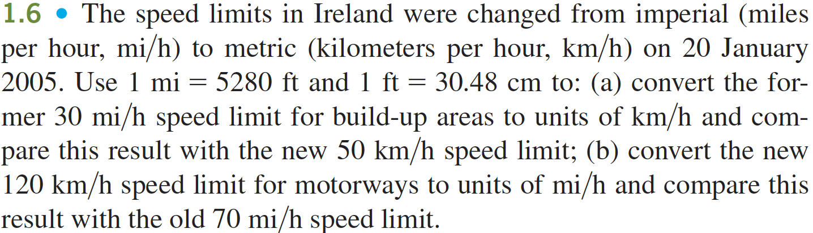

$$v=\frac{30\frac{mi}{hr}·5280\frac{ft}{mi}·30,48\frac{cm}{ft}}{100\frac{cm}{m}·1000\frac{m}{km}}≈48\frac{km}{hr}$$

$$v=\frac{120\frac{km}{hr}·1000\frac{m}{km}·100\frac{cm}{m}}{30,48\frac{cm}{ft}·5280\frac{ft}{mi}}≈75\frac{mi}{hr}$$

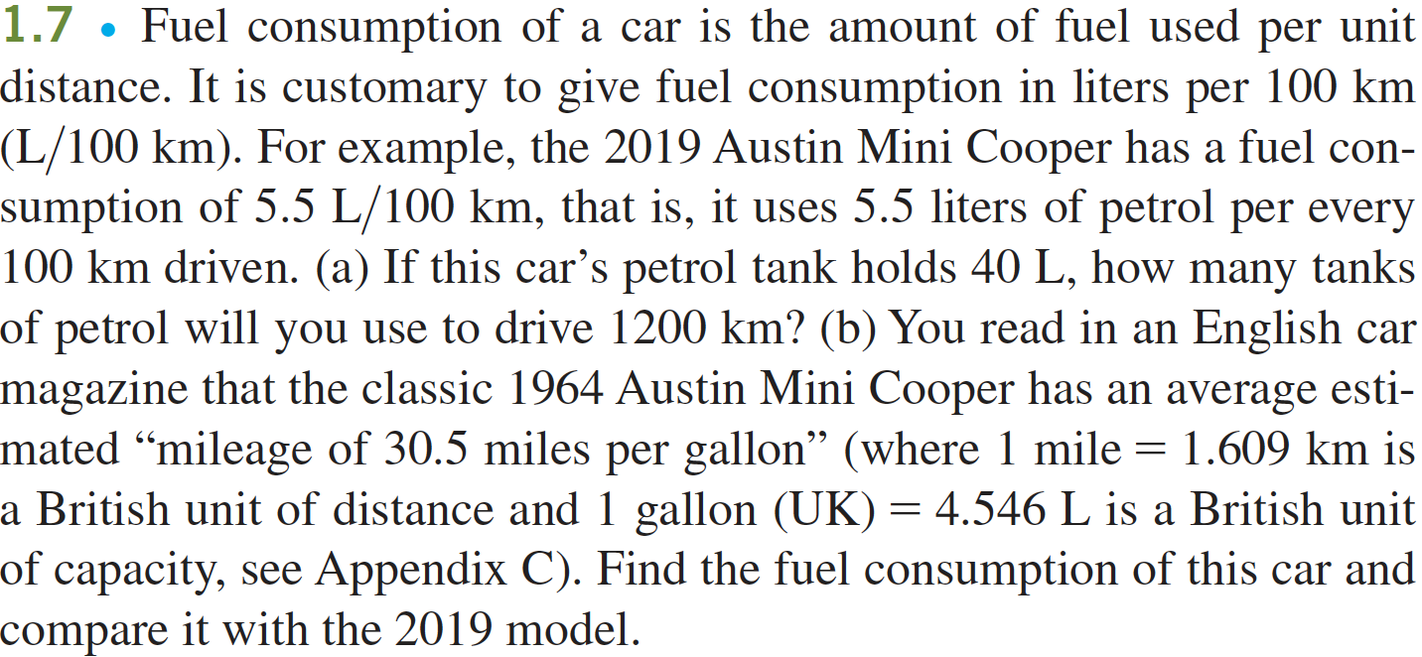
a
$$d_{1 tank}=\frac{40 L}{5,5\frac{L}{100 km}}=\frac{8000}{11}km≈7,3·{10}^{2} km$$
$$n=\frac{1200 km}{7,3·{10}^{2} km}≈1,6$$

B
$$\frac{30,5\frac{mi}{ga}·1,609\frac{km}{mi}}{4,546\frac{L}{ga}}=\frac{10,7950945886493km}{L}$$

$$\frac{100}{10,7950945886493\frac{km}{L}}=9,26346676991110\frac{L}{100 km}$$

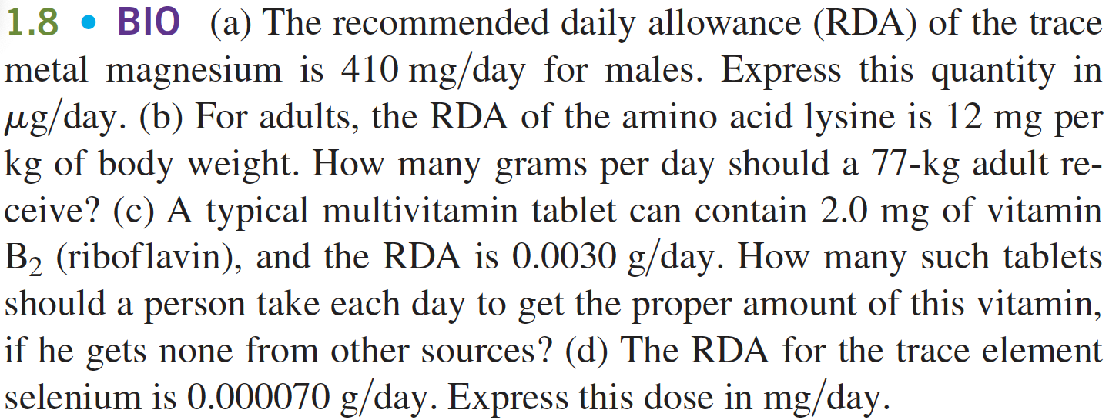
a
$$410\frac{mg}{day}=410\frac{mg}{day}·{10}^{3}\frac{μg}{mg}=410.000\frac{μg}{day}$$
B
$$RDA_{lysin}=\frac{12\frac{\left(\frac{mg}{kg}\right)}{day}·77 kg}{1000\frac{mg}{g}}≈0,92\frac{g}{day}$$
C
$$n_{piller}=\frac{3,0·{10}^{-3}\frac{g}{day}·{10}^{3}\frac{mg}{g}}{2,0\frac{mg}{pill}}≈1,50000000000000\frac{pill}{day}$$
D
$$0,000070\frac{g}{day}·{10}^{3}\frac{mg}{g}≈0,07\frac{mg}{day}$$

A
$$\frac{22}{7}≈3,14286$$

B
$$\frac{355}{113}≈3,14159$$

C
A er akkurat til 3 betydende cifre og b er mindst akkurat til 6

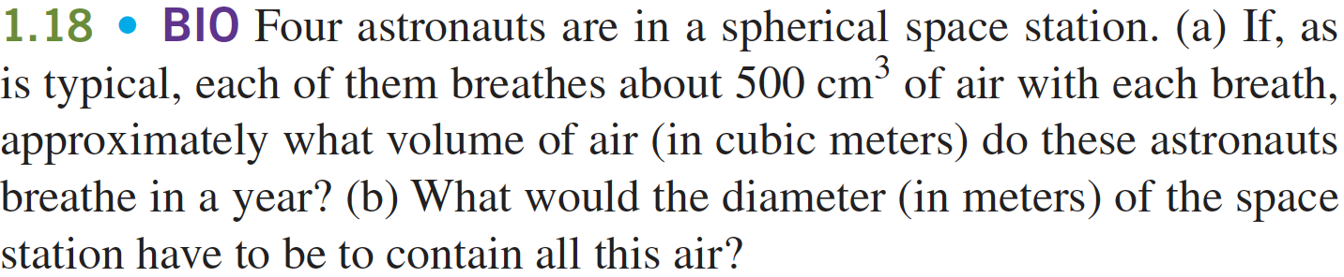
A
Antagelse: $Respirationsfrekvens≈10 min^{-1}$
$$V_{pr. år}=4\left(\frac{500 cm^{3}}{{100}^{3}\frac{cm^{3}}{m^{3}}}·10 min^{-1}·60\frac{min}{hr}·24\frac{hr}{day}·365\frac{day}{yr}\right)=1,05·{10}^{4}\frac{m^{3}}{yr}$$

b
$$r=\sqrt[3]{\frac{V}{\frac{4}{3}·π}}$$

$$d=2r=2·\sqrt[3]{\frac{V}{\frac{4}{3}·π}}=2·\sqrt[3]{\frac{10511 m^{3}}{\frac{4}{3}·π}}=27,2 m$$

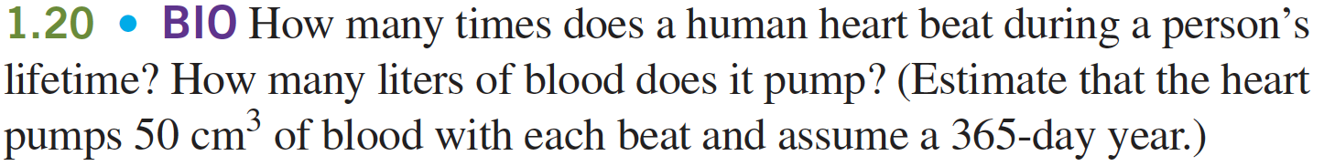
A
Antagelse: $puls=70 min^{-1}$
$$n=70 min^{-1}·60\frac{min}{hr}·24\frac{hr}{day}·365\frac{day}{yr}·80 yr=2,9·{10}^{9}$$

b
$$V=\frac{50\frac{cm^{3}}{slag}·2,9·{10}^{9}slag}{1000\frac{cm^{3}}{L}}=1,5·{10}^{9} L$$

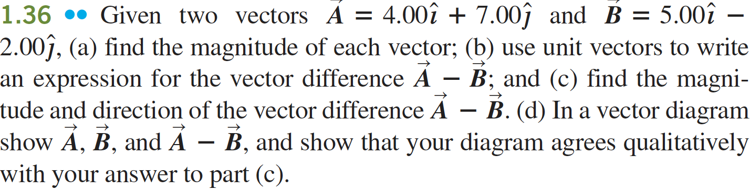
A
$$\left|A\right|=\sqrt{{4,00}^{2}+{7,00}^{2}}=8,0623$$
$$\left|B\right|=\sqrt{{5,00}^{2}+{2,00}^{2}}=5,3852$$

B
$$A-B=\left(\begin{aligned}4,00 \\ 7,00\end{aligned}\right)-\left(\begin{aligned}5,00 \\ 2,00\end{aligned}\right)=\left(\begin{aligned}-1,00 \\ 5,00\end{aligned}\right)$$
$$\hat{A-B}=-1,00 \hat{i}+5,00 \hat{j}$$

